Phonics

In phonics this half term we will be learning lots of new graphemes and continuing to develop our phonics skills using Monster Phonics.

R.E

This term our topic is ‘Who is a Muslim and what do they believe?’
DT.

This term our topic is called ‘Fab Fruits and Amazing Vegetables! We will be looking at the products we need to use, designing and making our own smoothies!

Science

The new topic for this half term will be ‘comparing materials. The children will be looking at a range of different materials and their physical properties. They will be able to compare and group together a variety of everyday materials and be able to describe these.

Music

This term we will be focusing on Tempo. Our topic is Traditional Tails.

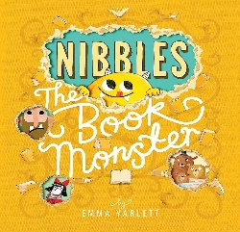

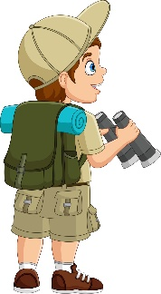
Maths

We will be using our Mastery Maths scheme ‘White Rose Maths’
This half term we will be mastering;
- Position and Direction
- Numbers to 20
- Addition and subtraction within 20.

History

This term our question is ‘What is History?’ We will be looking at the past and present and creating our own time lines and family trees. We will be comparing the toys our grandparents played with to the toys we play with now.

English

Book bags will be given out on Thursday and
need to be returned on Tuesday.
Our book this term is Nibbles the Book Monster
by Emma Yarlett. The children will be learning to
join words using ‘and’. We will be punctuating
sentences using capital letters and full stops and
using capital letter for people’s names. The children will be sequencing their sentences to form a short narrative and will be writing a diary entry.
Computing

In computing we will be learning about Coding and Programming.
You’re an
Explorer!
Year 1 Autumn 2

PHSEE

This term we will be looking at Celebrating Differences. We will be exploring anti-bullying, what it is like to be unique and respecting our similarities and differences.
P.E - Please ensure your child comes to school dressed in our PE uniform - plain dark coloured joggers/ leggings, a plain white t-shirt/ polo-shirt, school jumper/cardigan and trainers. PE will be on Wednesday afternoons.
This half term, Year 1 will be mastering athletics!

