Science

The children will be learning
about the changing seasons.
We will be observing changes
across the four season. We
will be describing what type of
weather is associated with the different seasons and how the length of the days varies in the seasons.

R.E
This term our topic is ‘Who is a Christian and what do they believe?’ We will be visiting our local church.
Music

In music this term we will be exploring Pulse and Rhythm. Our unit is inspired by Animals.

Art

This term we will be looking at mark making and studying the Artist Paul Klee. We will be creating pictures in the style Klee using various mark making techniques.

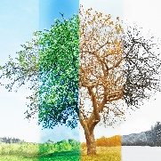

Phonics
In phonics this half term we will be learning lots of new graphemes and continuing to develop our phonics skills using Monster Phonics.



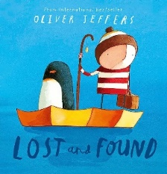
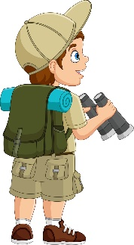
English

Book bags will be given out on Thursday and need to
be returned on Tuesday.
Our book this term is Lost and Found
by Oliver Jeffers. Our writing outcome
for this is to write an adventure story based
on the structure of ‘Lost and Found’ but
using our own unique animals. We will be
composing sentences orally before writing them, combining words to make sentences, leaving spaces between words and beginning to use capital letters and full stops.

Maths
We will be using our Mastery Maths scheme ‘White Rose Education’
This half term we will be mastering;
- Place Value: Numbers to 10
- Number bonds

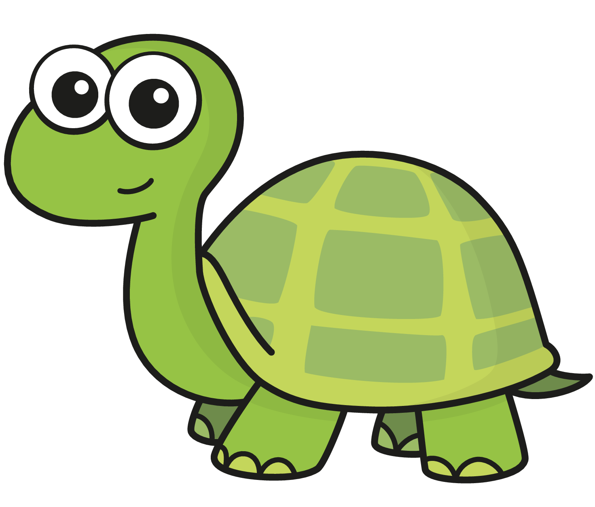

Geography

In Geography this term we are exploring our local area. Our question is ‘Which is the safest park to walk to?’
In this unit we will be collecting information about our local area, conducting a road survey and creating our own maps.

You’re an
Explorer!
Year 1 Autumn 1

P.E
Our P.E sessions for this term will be on Tuesdays.

Please ensure your child comes to school dressed in our PE uniform - plain dark coloured joggers/ leggings, a plain white t-shirt/ polo-shirt, school jumper/cardigan and trainers.

This half term, we will be learning to dance!

PHSEE

This term we will be looking at ‘Being Me in my World- Who am I and how do I fit in?’

Computing
In computing we will be learning about online safety and how technology impacts our lives. We will be covering topics such as ‘looking after myself online’ and ‘my personal information and my work belong to me.’

