Geography:
We will be taking part in a Local Area Study, titled: Do we need more play facilities in our local area?

Science
We will begin our time in Juniors exploring the key scientific skills we will be using throughout Key Stage 2.
English
We will be exploring the book ‘Seal Surfer’ by Michael Foreman, using the ‘Pathways to Writing’ scheme, which build on the pattern of work in Year 2. After immersing ourselves in the story, exploring vocabulary and setting we will write a letters from one character to another, and diary entries.
Maths
This year we are following the White Rose Maths scheme. We begin the year by looking at the place value of numbers to 1000. We will then move on to our addition and subtraction topic where we will begin looking at adding multiples to 100.
Computing
Our main focus for this half term is emails. We will look at how to write, edit and send emails. We will also be looking at internet safety.
RE
We will explore how Christians show their beliefs, the celebration of Holy Communion and how Christians try to serve and make a difference.
Music
This half term we will begin our ukulele lessons.

We will learn simple chords and how to play along to well-known songs!

PSHE
We will be focusing on what it means to work as a team, how we can be a good teammate, and what to do if things don’t go as smoothly as we want.
Spanish
We will be learning how to be polite when meeting and greeting people and how to exchange simple information e.g. names.
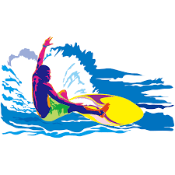

Splash!
DT
As fruit ripens and harvests are collected, we will be exploring seasonal foods and cooking skills.

