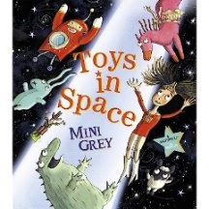
Geography

In Geography we will be comparing the capital cities in the UK and answering the question, ‘Are all Capital Cities the same?’ We will conclude our exploration by deciding which city we would prefer to visit.
English

Book bags should be returned to school every Tuesday.
This half term our book is ‘Toys in Space’ by Mini Grey.
We will be punctuating our sentences, using
conjunctions like ‘and’, using the prefix un-,
using suffixes such as –ed, -er and we will
be leaving spaces between our words.

Maths

Using our White Rose Maths scheme this half term we will be mastering;
- Multiplication and Division
- Fractions
- Position and Direction


Science

This half term we will be starting a new topic called ‘identifying materials’. We will be looking at different materials used to make toys, we will try and find other objects made from different materials. We will be looking at the different textures, weight and feel of different materials. We will also be learning about the difference in liquid and solid materials.

Computing
We will be using painting applications to create posters and art work. We will make a gallery of all our great work!
Phonics
In phonics this half term we will be recapping over everything we have learnt so far, in preparation for the Phonics Screening Assessment.

R.E
This half term we will be exploring what it means to belong in a faith community.
PHSEE
In PSHEE we will be exploring Relationships. We will be discussing signs of a healthy relationship and how we build them with one another.
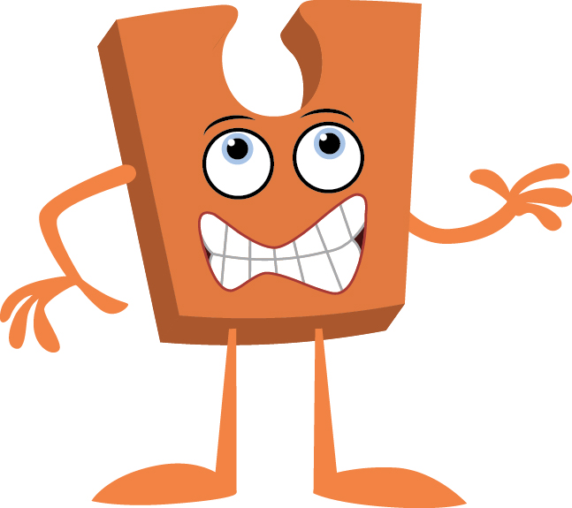
Music

In music we will be exploring both Pitch and Tempo. Building on the skills already taught this year.
The theme for this terms Music is Superheroes!

Out of This World
Year 1 Summer 1!
Art

Explore famous paintings of self-portraits before creating our own. We will be using various mediums to create these including clay!

P.E
Please ensure your child comes to school dressed in plain dark coloured joggers/ leggings, a plain white t-shirt/ polo-shirt, school jumper/cardigan and trainers.
This half term, the topic for PE is Rounders! The children will be learning new skills and building upon the ones they already have.

