
Spanish Curriculum Map – 2025 / 2026 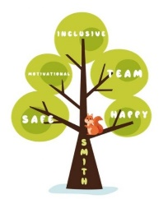

 | AUTUMN TERM |  | SPRING TERM |  | SUMMER TERM
YEAR 3 | Meet & Greet | My Body | Time to Eat | The People Around Me | All About School | Tell Me When
YEAR 4 | My Town | Let’s Go | Shopping | The Wider World | My Routine | Free Time
YEAR 5 | All About Me | The Way We Look | Eating Out | My World | In the Classroom | Our Past
YEAR 6 | Exploring a Spanish Town | At the Shops | Festivals and Celebrations | SATS | Spanish Around the World | Recap and KS3 Prep

