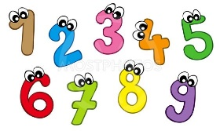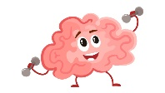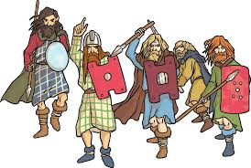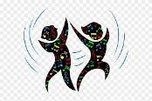

**Maths**

We will learn about place value to 4 digits, and counting in 25s, 100s and 1000s. We will compare numbers using language such as 'greater', 'smaller', 'less' and 'more', and will learn about rounding numbers to the nearest 1000, 100 and 10. We will add and subtract 4 digit numbers. We will be learning our 6 and 9 times tables and using Times Tables Rock Stars, which you can log in to at home as well.

**PSHE and Wellbeing**

Our topic in PSHE will be Being me in my world where we will look at our school community and discuss ways to help others feel welcome. We will focus on wellbeing and look at different strategies that will help us deal with difficult feelings.

**Science**

The children will be learning about the human digestive system. We will be learning key vocabulary and doing a practical experiment to demonstrate how it works.

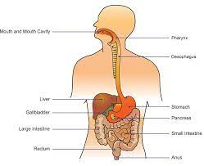

**English** – We will be enjoying Counting on Katherine by Helaine Becker and writing a biography based on this inspiring text. We will read about Shackleton’s journey and write a newspaper report. We will be using noun phrases, pronouns and fronted adverbials.

The children will be given spellings each week to practise at school and at home. We will also send the children home with a reading book each week.

**History**

We will be finding out all about Anglo-Saxons, Picts and Scots, what artefacts can teach us about the past and all about the way of life in England from 400AD – 1066.

**Into the Unknown**

**Year 4 Autumn 1**



**P.E - Our P.E sessions will be on Thursdays. Please ensure your child comes to school dressed in plain dark coloured joggers/ leggings, a plain white t-shirt/ polo-shirt, school jumper/cardigan and trainers.**

This half term the children will be taking part in Dance. We will dance to

different rhythms and tempos and use our bodies to produce rhythm on our own and as a whole class.

**R.E**

We will be finding out

what Hindus believe and how they express their faith.

**Computing**

As well as using the ipads, we will be focusing on online safety, and we will be learning how to create a keynote presentation.

**Art**

We will finding out about the artist Sonia Delaunay and doing some art work in this style.

