**Personal, Social and Emotional development**

The children will be supported to develop purposeful friendships in the classroom and become more outgoing with unfamiliar people through bonding with other children during continuous provision. The children will be introduced to the class rules and begin to understand why they are important and how they keep us safe.

**Physical Development**

The children will start taking part in group activities and learning outdoor team games to support with listening and turn taking skills. We will be exploring dance and movement through our PE topic and we will also be taking part in weekly basketball sessions with Mersey Mavericks!

**Communication and Language**

During this half term, the children will be welcomed into the setting and encouraged to share information about themselves and their families. Language will be modelled by their teachers and children will be supported to develop their listening skills. We will also enhance communication development through lots of songs and nursery rhymes.

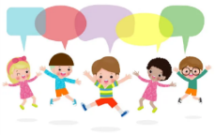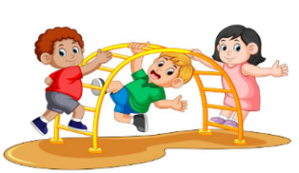

**Understanding the World**

The children will begin to make sense of their own life story and their family history. They will be encouraged to talk about who is in their family, the houses they live in and their local area. The children will make comparisons between themselves and others and develop positive attitudes about the similarities and differences between people.

**Topic: All About Me**

**Term: Autumn 1**

**Literacy**

This half term we will be looking at the book ‘Peace at Last’ by Jill Murphy. We will be making predictions about what we think might happen next in the story and also looking at the sequence of the text. We will be going on lots of environmental sound hunts in our outdoor area too to bring the story to life!

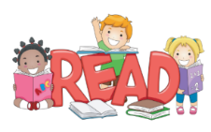



**Expressive Arts and Design**

The children will take part in pretend play and begin to develop complex stories in the home area and with small world equipment.

The children will also paint self-portrait and think about what makes them unique as part of their ‘All About Me’ topic.

**Mathematics**

The children will begin to explore numbers 0-5 and become more confident at recognising the digits as well as saying the numbers. We will also be using comparative language such as ‘more than’ and ‘less than’.

**Outdoor Learning**

The children will explore the natural world through our amazing outdoor spaces including our playground and Wild Garden! The children will also be encouraged to take part in outdoor games to support their gross motor, fine motor and social skills.

