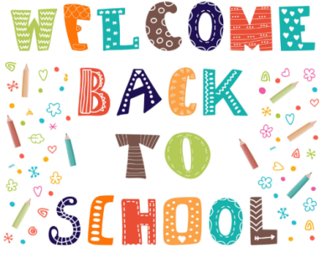

**Nursery Newsletter Autumn 1**

### We hope you had a lovely summer and are ready for a fabulous year! We have lots of fun things planned and can’t wait to get started.

**Useful information**

Please make sure children come to school wearing clothes which make it easy for them to access the toilet as well as Velcro shoes (if possible.) Children need to also bring in a full change of clothes, including underwear and socks, in case of any accidents. We often access muddy areas, such as the Wild Garden, and so it would be helpful to have a pair of wellies for each child to keep in school.

Children can bring a water bottle and are offered fruit and milk/water for morning snack. If they are staying for the full day, they will also need to bring a healthy packed lunch. Please be aware that we are a **nut free school** and, therefore, any packed lunch items cannot contain nuts.

### **P.E**

This term we have P.E. on **Wednesdays** and basketball with Mersey Mavericks on a **Thursday**. Children need to come to school wearing clothes which are easy to move around in and trainers on these days.

### **Curriculum**

Our creative curriculum topic for this half term is **‘All About Me!’** Please see our topic web to see all of the exciting things we have planned!

Thank you for your support and we look forward to welcoming you to (or back to!) our setting.

The Nursery Team