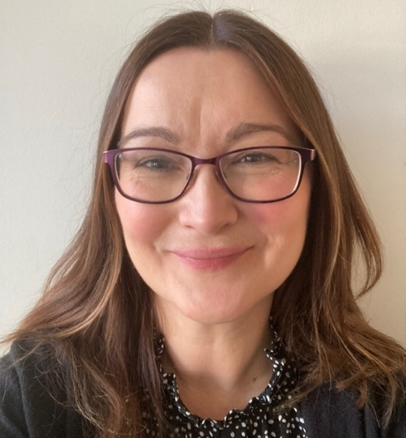
Hello Nursery! I am Mrs Cahill and I joined the lovely team at St Michael in the Hamlet in May 2024. It is such a joy to be part of a place where children are encouraged to explore, laugh, learn and grow every day.
Here is a little bit about me:
My favourite thing about being a teacher is…
Seeing the world through the children’s eyes. Their curiosity, imagination, and excitement for learning are so inspiring and I feel lucky to help guide them through these magical early years.
My interests and hobbies are…
I especially love using music to bring us all together – singing songs, making sounds and moving to the beat. Music is my favourite subject and I also enjoy playing the piano.
My interests and hobbies are…
When I am not at school, I love going for long walks in nature, visiting my family in beautiful Wales and spending time relaxing and recharging.
Mt favourite food is…
I’m a big fan of Italian food – I can never say no to a bowl of pasta!
I’m so excited to be part of your child’s journey at St Michael in the Hamlet and I am passionate about helping every child feel safe, happy and ready to shine.

