**Personal, Social and Emotional development**

The children will begin to play with increasing confidence on their own and with other children. The children will become more confident at managing classroom transitions with staff support and guidance. They will become more independent at using the toilet with help and then independently.

**Physical Development**

The children will take part in group movement activities and clap and stamp in time to music. They will develop ball skills by participating in basketball lessons with the Mersey Mavericks and developing their gross motor skills.

**Communication and Language**

The children will be encouraged to share their weekend news during circle time with adult support. They will begin listen to others talk with interest and develop conversations with other children. The children will listen to simple stories and understand what is happening with the help of the pictures.

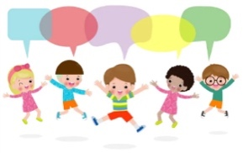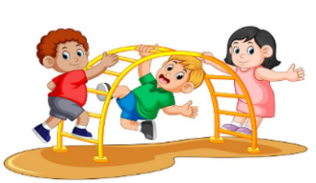

**Literacy**

This half term we will be looking at Traditional Tales. We will be focusing on enjoying longer stories and continuing to develop vocabulary. We will begin to name the parts of a book, such as, cover, title and blurb. We will develop our range of nursery rhymes.

**Understanding the World**

The children will be celebrating difference and talking about what makes them special and unique. They will talk about differences in others, begin to include others in their play and solving problems with others. The children will learn about different festivals that take place throughout this period and are given the opportunity to participate in celebrations to mark these special occasions.

**Term: Autumn 2**

**Topic: Once Upon a Time**

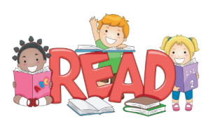



**Mathematics**

The children will be exploring first patterns by choosing blocks to copy simple creations and make simple patterns with objects. We will be singing number songs, develop counting skills and begin to order numbers by name. We will also being subitising up to three objects.

**Expressive Arts and Design**

The children will take part and enjoy action songs, such as, ‘Twinkl, Twinkl, Little Star’ and other nursery rhymes. They will explore making different sounds using their voices and percussion instruments.

The children will also create a festive folder containing a card and different crafts.

**Outdoor Learning**

The children will begin to develop their skills in our wild garden by working in teams to build different structures using different materials. They will use different vocabulary from our story and discuss how our different structures could be make stronger.

