**Personal, Social and Emotional development**

The children will be supported to develop purposeful friendships in the classroom and become more outgoing with unfamiliar people, through key worker groups and bonding with other children during continuous provision. The children will be introduced to the class rules and begin to understand why they are important.

**Physical Development**

The children will start taking part in group activities learning outdoor team games to support with listening and turn taking skills. We will be focusing on the children becoming increasingly independent by putting on coats and doing up zips.

**Communication and Language**

During this half term, the children will be welcomed into the setting and encouraged to share information about themselves and their families. Language will be modelled by their teachers and children will be supported to develop their listening skills.

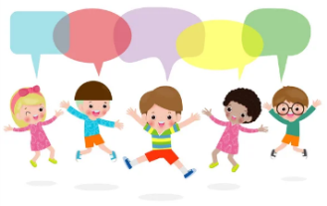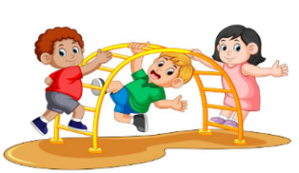

**Understanding the World**

The children will begin to make sense of their own life story and their family history. They will be encouraged to talk about who is in their family, the houses they live in and their local area. The children will make comparisons between themselves and others and develop positive attitudes about the similarities and differences between people.

**Topic: All About Me**

**Term: Autumn 1**

**Literacy**

This half term we will be looking at books about families. We will be focusing on enjoying longer stories, develop a wider range of vocabulary, understanding print has meaning and how a story is sequenced. We will also begin to build our bank of nursery rhymes.

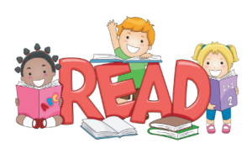



**Mathematics**

The children will begin to explore numbers 0-5 and take part in finger rhymes with these numbers. They will also compare amounts, says ‘lots’, ‘more’ or same.

**Expressive Arts and Design**

The children will take part in pretend play and begin to develop complex stories in the home area and with small world equipment.

The children will also paint self-portrait as part of their All About Me topic.

**Outdoor Learning**

The children will explore the natural world as they explore the wild garden. The children will also be encouraged to take part in outdoor games to support their gross motor, fine motor and social skills.

