

Curriculum Policy 2024- 2025

St. Michael in the Hamlet Primary School

Intent

Our St. Michael in the Hamlet Thematic Curriculum works hand in hand with the 2014 Primary National Curriculum and our NEW school vision (2020).

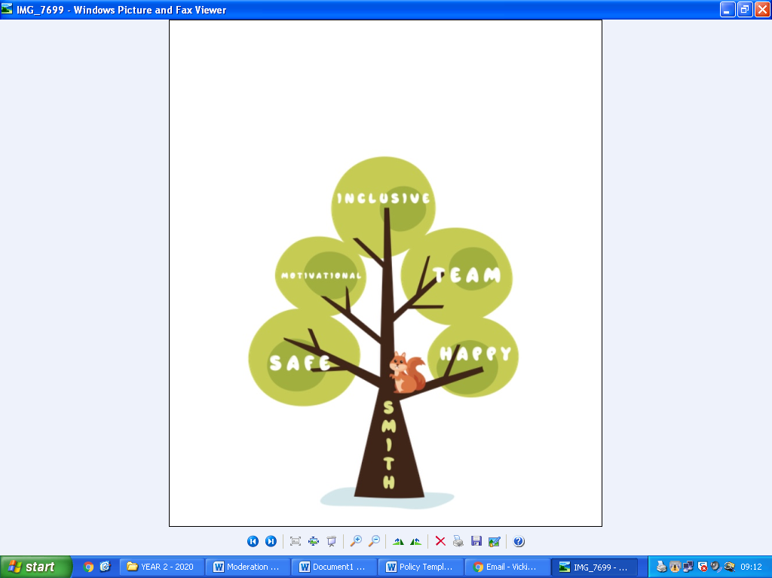

**S.M.I.T.H**

**S**afe, **M**otivational, **I**nclusive, a **T**eam and **H**appy

We teach through a carefully planned thematic approach, valuing a broad and balanced curriculum which gives children the opportunities to achieve their full potential. We have designed our curriculum to build on children’s prior learning over time, linking key concepts across subjects as well as developing a breadth of subject knowledge. Topics are designed to **motivate** children’s natural curiosity and stimulate their creativity, in **safe** and **inclusive** environment.

We encourage our children to celebrate success and build on disappointment in order to develop resilience.**We want to equip them with not only the minimum statutory requirements of the National Curriculum but to prepare them for the opportunities, responsibilities and experiences of later life.** The topics have been carefully chosen to ensure the curriculum is appropriately balanced across each year and each key stage. We aim to provide all pupils with equal access to a rich, broad, balanced and differentiated curriculum matched to their ages, abilities, interests and special needs.

The thematic curriculum will be the means of providing all children with opportunities for enjoyment and achievement. It will foster economic well-being, improve learners’ health, keep them safe and help them to make a positive contribution to the school and the community. The S.M.I.T.H. thematic curriculum will enable all learners to enjoy their education. The goal for our pupils is to feel **safe** and inspired to fulfil their true potential. As well as feeling a sense of **team** spirit from living within our culturally diverse community.

The exciting curriculum that we provide will help the children to understand who they are and the issues facing the world around them. It will increase their understanding of history, time and place and deepen their knowledge of, and respect for, different cultures and beliefs.

Implementation

Our curriculum has high expectations for all children and we embody this in day to day teaching. The curriculum will be carefully planned and structured to ensure that learning is continuous and that pupils make good progress and achieve their full potential. To increase pupils’ knowledge, skills and understanding as they grow and develop and strengthen their connection with the diverse world around them.

The National Curriculum will be taught to all pupils and we promote the benefits of cross-curricular learning. Teachers’ planning shows that learning is carefully planned for each year group ensuring progression throughout the School years and is responsive to individual children’s needs.

We empower our staff to organise their curriculum as they see fit to best suit the needs of the pupils in their care. They are best placed to make these judgements. Staff develop year group specific long-term curriculum maps which identify when the different subjects and topics will be taught across the academic year.

Our short-term plans are produced on a weekly basis. We use these to set out the learning objectives for each lesson, identifying engaging activities and resources which will be used to achieve them.

We encourage staff to teach a weekly lesson for each of the foundation subjects and the core subject of science. This helps to ensure sufficient time is allocated to each subject area.

English and mathematics underpin all the work that we carry out, with reading at the heart of all work, enabling children to access the full curriculum. These subjects are taught discreetly, whereas other subjects may be taught as part of a topic, for example, they may learn history alongside their geography, or science alongside their design technology reinforcing the learning through a multi-layered approach.

Opportunities will be taken to culturally enrich the curriculum through first hand experiences such as: educational visits out of school; involvement of parents, visitors, artists, actors and musicians; the use of the school grounds, the locality and the wider environment. In addition to this they will have a series of memorable learning experiences, which may include; STEM workshops, LJMU dance students, global students, topic themed days and themed weeks.

Members of staff will be given responsibility for leading, managing, monitoring, evaluating and reviewing the curriculum. Teachers will be given opportunities to use their subject expertise to enhance the curriculum.

Children’s work and achievement within the curriculum will be celebrated and displayed to enable it to make a significant impact on the visual appearance of the school and to contribute positively to its ethos.

Impact

We are constantly reviewing the curriculum offer that we offer our children at St. Michael in Hamlet primary school. In-depth monitoring ensures that all children are receiving the broad and balanced curriculum they are entitled to with clear progression in all subjects. Senior Leaders work with Subject Leaders to review learning, evaluate pupil voice and provide feedback to move practice forward, celebrating positives and highlighting areas of development.

Our whole school team work together to embody our vison and values through the curriculum. We aim to ensure that all children make good progress in all subjects and we do not confuse this with coverage. We plan activities so learning is embedded and knowledge is retained.

We use both formative ‘balance’ and summative assessment information every day, in every lesson. Staff use this information to inform their short-term planning and short-term interventions – including in the foundation subjects. This helps us provide the best possible support for all of our pupils, including the more able.

Assessment information is analysed by Subject Leads, the Assessment Lead and Headteacher as part of our monitoring cycle. Pupil progress reviews are conducted half termly (formative) and termly (summative). This process provides the SLT and Governors with an accurate and comprehensive understanding of the quality of education in our school.

We set out our monitoring cycle at the beginning of each academic year. This identifies when monitoring for all year groups is undertaken in all subject areas. Monitoring includes: book scrutinise, lesson observations and/or learning walks, pupil/parent and/or staff voice.

All of this information is gathered and reviewed. It is used to inform further curriculum developments and provision is adapted accordingly.

Reviewed November 2024

Next review date: November 2025