Year 5 Spring Newsletter
A warm welcome back from all the staff in Year 5. It has been good to settle back in to routine and be back together! We hope that the children are excited to embark on another half term of adventure, as we explore the world of ancient heroes, villains and monsters as part of our new topic – ‘Raiders, Invaders and Crusaders’. We have some amazing activities and topics planned that we hope they will love. If you want to keep updated on what is going on please keep checking our school Twitter (@st_michaels_ham) and your child’s Class Dojo page, where we will share the children’s work and regular updates.
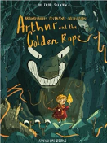
English
The text we will be exploring will be ‘Arthur and the Golden Rope’ by Joe Todd-
Stanton, which will lend itself to the study of myths and legends. The chosen text
will form the basis of our reading study. Later in the term, we will also look at
biographies inspired by ‘The Darkest Dark’. There will also, be daily focus on
enhancing reading, writing and spelling to ensure that children continue to develop
their ‘reading to learn’ skills.
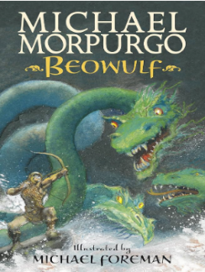
Reading
Our shared reading text will be ‘Beowulf’, the Michael Morpurgo edition. This
version is a take on the Old English epic poem, set in Denmark. We will follow
the hero of the story, Beowulf, as he battles with the monstrous Grendel, a
sea-hag and finally a death-dragon of the deep. Through shared reading, we will
be predicting, inferring, retrieving information, understanding new vocabulary
and explaining parts of the narrative.
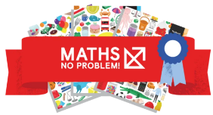
Maths
The focus for this half term and into Spring 2 will be ‘Fractions’. We will continue following the Maths No Problem scheme to compare and order fractions, add, subtract and multiply mixed numbers and improper fractions.
Later in the half term the children will also learn to multiply proper fractions and mixed numbers by whole numbers. We will also use ‘Fluent in 5’ activities at the start of each day to refresh our skills from previous Maths topics.
Home Learning

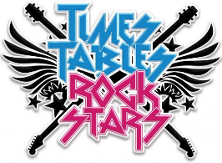
Each child has an Active Learn Primary account that we use to allocate electronic books and other resources. The website sends us an activity log each week and we encourage the children to access the electronic library as much as they can both in school and at home. To support the maths curriculum, all children are encouraged to continue learning and practising their times tables up to 12 x 12. Regular practice is the best way to make times tables stick, so having them up around the house, listening to times tables songs and regularly using Times Tables Rock Stars (ttrockstars.com) will help!

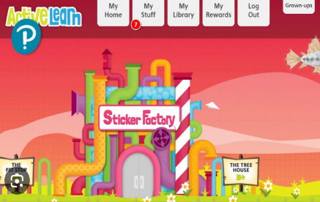

Science
This half term, we will be learning about separating mixtures and reversible and different types of changes. We will formulate their own question before planning how we will answer it, predicting possible outcomes and carrying out a fair test. We will investigate reversible and irreversible changes as well as dissolving, filtering and evaporating.
Computer Science/Digital Literacy – We will use iMovie to create our own trailers and will also learn about random numbers and simulations in coding.
Geography - We will learn about the region, Scandinavia. We will begin by locating the region and knowing its countries and significant cities. After learning about the physical geography of the region, the focus will then shift to human geography and particularly tourism.
RE – We will explore in depth from different religious and non-religious groups about belief in God as well as the religions followed within our local community. We will look at what matters most to Christians and Humanists.
Art - This term we will be learning all about street art as part of a brand new unit of teaching! We will be looking at graffiti lettering, how graffiti art is used to send messages or create satire, how it can be used to improve public spaces and design our own pieces inspired by what we have learnt about.
Music – The Singing Schools Programme will begin their workshops with us – singing coaches from Liverpool Cathedral will visit every week until July to develop our musical skills.
Spellings - Spellings are set on a Monday in Year 5. We will test three spellings each day to support the cognitive load placed upon children. Children should learn their three spellings each night prior to being tested the day after. Spellings will be tested informally using different strategies. PE - PE will be held on a Monday with the class teacher. Please can children attend school on Monday in full PE kits: white top, dark shorts/jogging bottoms/leggings, school jumper, cardigan or hoodie and trainers.
The Year 5 curriculum is interesting, fun and knowledge rich. We hope you enjoy learning it just as much as we do teaching it. If you have any resources or expertise that you would like to contribute to enhance learning, please get in touch. Thank you for all your support, we look forward to working in partnership with you.
The Year 5 team – Mrs Amal, Mrs Brackenridge and Mr Hawkins

