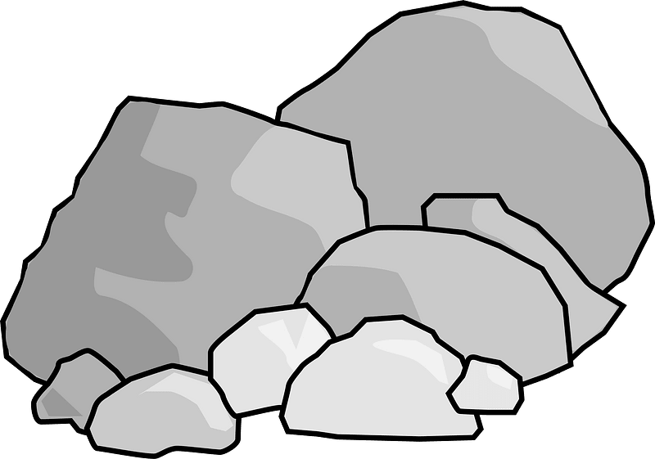

**Music**

This term we will be learning exciting songs based on ‘The Heroes of Troy’, each one linking to an episode of the story of the Trojan War.

**English**

Our key Pathways to Writing text is ‘Stone Age Boy’ by Satoshi Kitamora. In this book a boy from modern times falls back to the stone age. We will explore the structure and vocabulary of the book, write and punctuate conversations between characters, write diary entries and eventually write a historical story from the boy’s point of view.

**Maths**

We continue to follow our scheme, ‘Maths No Problem’. This half term we will continue to practise fast recall and efficient methods of multiplication and division as well as exploring measurement including length, mass and volume.

**Computing**

We continue to use coding to create and control animations. We talk about debugging code, and encourage the children to predict and then investigate what they are coding.

**RE**

We will be exploring the question ‘Why is the Bible important for Christians today?’ We will give examples of how and suggest reasons why Christians use the Bible today.

**PE**

This term we will begin our work on gymnastics, symmetrically and asymmetrically with partners. We will be focussing on starting and finishing positions, and spins.

**We Will Rock You**

**DT**

We will be learning about famous British inventors. We will explore their inventions and the impact they have had on our daily life.

**Science**

We will investigate the properties of different types of rocks and soils, and group them. We will find out how fossils are formed.

**PSHE**

This half term's PSHE unit is all about keeping safe. We will learn about assessing risks and dangers and also how to decide if a situation is safe or unsafe.

**Geography**

We will learn about the human and physical geography of India, its influence on other countries and compare with Great Britain