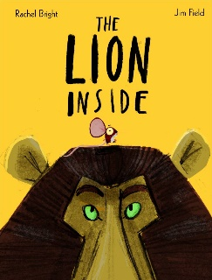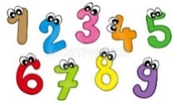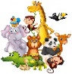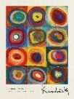

**PHSEE**

Our topic this term is Keeping Safe. We will be learning what is safe to go onto and into our bodies, all about our feelings and how we can keeo safe online. We will also be looking at people who help to keep us safe.



**English** – **Book bags should be returned to school every Tuesday!**

This half term we will be focusing on the book ‘The Lion Inside’ by Rachel Bright. The children will write an adventure story upon the model text using a different small and large animal

in the African Savannah. We will continue to practice

to compose our sentences orally before writing,

joining words using ‘and’, using suffixes –s and –es,

using capital letters at the start of a sentence and for

people’s names, using full stops and leaving spaces

between our words.

**Maths**

We will be using our mastery scheme to delve into topics such as:

* Shapes and patters
* Height and length
* Numbers to 40

**Computing**

In this half term the children will be learning about algorithms and programs. We will be using the Espresso programming app to help us explore this topic.

**R.E**

We will be exploring Islam and what Muslims believe.

**Special event!**

We will be having a Jungle Boogie to kick off our new topic of ‘Animal Magic!’ The children should dress as their favourite animals and put on their dancing shoes ready for a boogie! ☺ Date for this TBC.

**Music**

In this term we will be looking at how to play tuned and untuned instruments musically. We will be looking at instruments like the drum, tambourine and woodblock.

**

**Year 1 Spring 1**

**Art**

The Children will be learning about colour creations. We will be looking at colours and objects associated with them, primary and secondary colours and how we can create them, creating different shades of colours and producing art work

based on Kandinsky.

**History**

This half term we will be looking at ‘Famous Queens’. We will be looking at what is a Monarch and where do they live. We will be exploring the Victorian and Tudor periods and comparing the reigns of Queen Elizabeth I, Queen Victoria and Queen Elizabeth II.

**P.E - Our P.E sessions for Spring term will be on Thursdays. Please ensure your child comes to school dressed in plain dark coloured joggers/ leggings, a plain white t-shirt/ polo-shirt, school jumper/cardigan and trainers.**

This half term our new topic is Dance. We will be acquiring and developing new skills!

**Science**

The children will be learning about types of animals. Children will recognise different animals live in the local environment, the similarities and differences between animals and classifying familiar animals according to their characteristics. We will gather information on animals and present

the data in tables.