Well done to our children who have worked so hard during the last half term!

A warm welcome back from Mrs Payne and I! We hope you had a lovely break, we can’t wait to get going with all the brilliant learning we’ve got planned this term including celebrations. The children have settled back into school wonderfully.
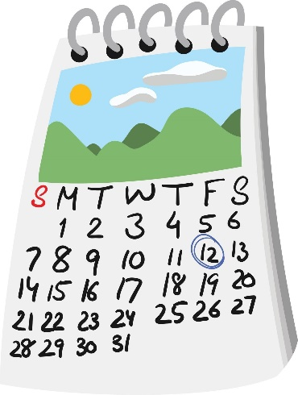
Key days in our week
Tuesday – P.E. day, please send your child in in appropriate clothing and trainers/pumps
Wednesday – we visit the wild garden, please send your child in in waterproof coats with a hood, a hat, scarf and gloves, we have wellington boots in school for your child to use.
Thursday – We have the lovely Anna with us teaching Spanish
Friday – we have the lovely Miss Fearon teaching Nursery.

Lunch Can we please ask that when preparing your child’s packed lunch, it contains a well balanced healthy lunch. Consisting of 4/ 5 items : a sandwhich or subsitute sandwhich, a piece of fruit, a yoghurt and two altnerantive snacks – one savory ie. crisp , crackers etc and one sweet snack – a cake, a bisuit or one chocolate snack
Home readers
We will continue to send home reading books in a book bag with a reading record. These will be sent home every Friday and we would like them back in by Thursday morning at the very latest.

Lunch
Can we please ask that when preparing your child’s packed lunch, it contains a well-balanced, healthy lunch. Consisting of 4/ 5 items: a sandwich or substitute, a piece of fruit, a yoghurt and two alternative snacks – one savoury ie. crisp, crackers etc and one sweet snack – a cake or a biscuit.

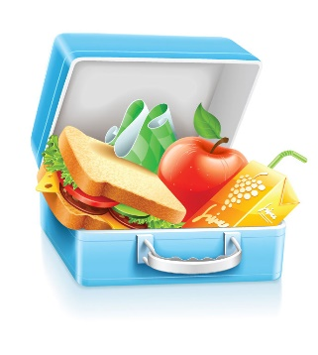

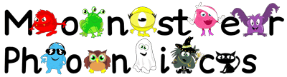
Class dojo
We will continue to communicate via Class Dojo, please check this regularly for updates.
We can share news, updates and send pictures of what the children are up to.
This is the most effective way to communicate with Mrs O’Neill.
Class text
This half term, our class text is The Three Little Pigs. We will be exploring story language, repeating predictable phrases and retelling traditional tales.
Phonics
As a school, we use Monster Phonics, to teach phonics. We are onto aspect 2 in phase 1: this is exploring instrumental sounds and how they can be varied.

