**Personal, Social and Emotional development**

The children will continue to develop purposeful friendships, through key groups’ times and sharing experiences with other children during continuous provision. They will also be continuing to develop their knowledge on how to look after themselves.

**Physical Development**

During this half term the children will be exploring dance through the use of nursery rhymes. We will be focusing on the different shapes, movements and actions we can make with our body; developing our gross motor skills.

**Communication and Language**

This term the children will be encouraged to share their ideas through sharing news and during circle time. The children will rhymes and develop their listening skills.

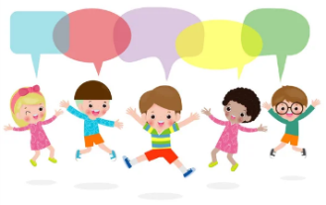

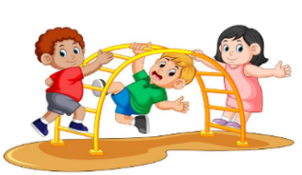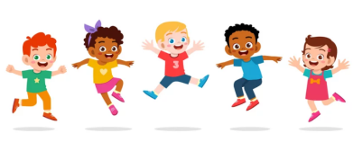

**Literacy**

This term we will be looking at books about traditional tales. We will be focusing on enjoying longer stories, develop a wider range of vocabulary, understanding print has meaning and how a story is sequenced. We will continue to build our bank of nursery rhymes.



**Understanding the World**

This term the children will learning about ‘People, Culture and Communities’. We will be making connections between the features of our families and other families. We will be identifying the similarities and differences between people and exploring different celebrations.

**Topic: Traditional Tales**

**Topic: Walking on Sunshine**



**Term: Autumn 2**



**Mathematics**

This term we will be developing our knowledge of numbers 0-5 and starting to explore numbers to 10. We will be looking at and exploring 2D shapes and their properties, using informal language and looking at repeating patterns.

**Expressive arts and design**

This term the children will explore different musical instruments. They will also be designing their own porridge. We will also look at creating homes for our characters from our traditional tales.

**Outdoor learning**

The children will explore the natural world as they explore the wild garden. The children will also be encouraged to take part in outdoor games to support their gross motor, fine motor and social skills.

