**Music**

We will learn songs from the story of the Trojan Horse. We will also begin our ukulele lessons.

**Computing**

Our main focus for this half term is internet safety, learning about guarding personal details and making safe and considerate choices online.

**RE**

We will explore how Christians show their beliefs, the celebration of Holy Communion and how Christians try to serve and make a difference.

**English**

We will be exploring the book ‘Seal Surfer’ by Michael Foreman, using the ‘Pathways to Writing’ scheme, which build on the pattern of work in Year 2. After immersing ourselves in the story, exploring vocabulary and setting we will write a letters from one character to another, and diary entries.

**PSHEE**

We will be focusing on what it means to work as a team, how we can be a good teammate, and what to do if things don’t go as smoothly as we want.

**Spanish**

We will be learning how to be polite when meeting and greeting people and how to exchange simple information e.g. names.

**Geography**

We will begin the year by looking at countries of the world, completing an in depth study of the continent we live on, Europe.

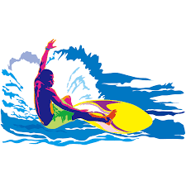

**Splash!**

DT

We will look at seasonal food and make our own apple crumble using fruit harvested from our wild garden!

**Science**

We will investigate how forces can be varied to control movement. We learn how magnets interact and test their strength.

**Maths**

We begin the year by looking at the place value of numbers to 1000. We will then move on to our addition and subtraction topic where we will begin looking at adding multiples to 100.