Clubs Provision Map Spring 1 2023
Monday | Tuesday | Wednesday | Thursday | Friday
Staff well-being fitness session (SB) | Young Singing Leaders  (all year groups)  HN/MF | Crochet Club  Year 5 and 6  RB/GB/MH | Year 6 Booster Lessons  Maths (HD) | 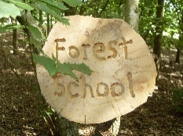  Outdoor Rangers  (LC/BF)
 | Year 6 Booster Lessons  Reading Comprehension  (PB)  GPS Session (JN) |  | 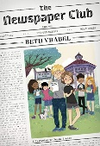  Newspaper Club  (All year groups)  SB/LM | Basketball Club Year 4
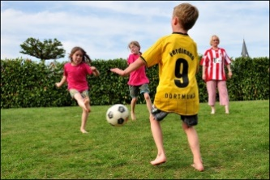
Football Training
Years 4, 5 and 6
BP/RB

