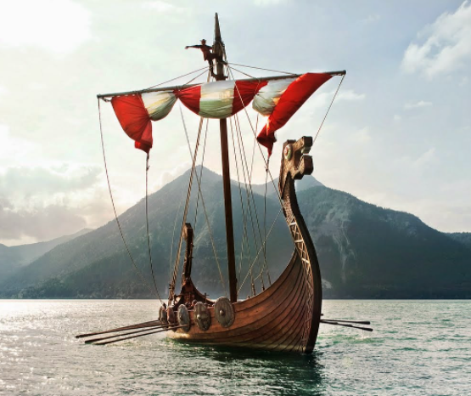

**Maths**

This term, we will encourage continuation of work with number, place value and multiples. We will develop our understanding of fractions, decimals and percentages as well as shapes, position and direction. Children will learn how to solve questions involving multiple steps/processes and check answers using estimation and inverse.

**History**

We will learn about the Vikings and Anglo Saxons, including key figures and invasions.   
We will also explore the Shang Dynasty and look at lifestyles, calendars and royal figures.

**Art and DT**

This term we will become street artists! We will develop graffiti lettering and look at how public spaces can be improved by this art. We will also look at how street art can be satirical. In DT we will sew drawstring bags.

**Science**

We will learn about properties and changes of materials in the early spring term and investigate reversible and irreversible changes. We will plan our own investigations.

**Geography**

In geography, we will link our studies to history and learn about Scandinavia. We will learn about the difference between climate and weather, what human and physical features are and compare places.

**Raiders, Invaders and Crusaders!**

**Computing**

We will look at the final elements of coding this term and will also use the iPads across the curriculum. We will also be looking at camera angles and movie trailers.

**PHSE and RE**

As part of RE, we will look at what people in our community believe as well as what matters to Christians. We will celebrate being ourselves and explore British values.

**English**

This term we will explore graphic novels, including ‘Arthur and the Golden Rope. We will use this as inspiration for our own Viking myths. We will then move in to a non-fiction unit where we will write biographies inspired by ‘The Darkest Dark’. We will continue to explore a range of texts and stimuli during our daily guided reading sessions.

**PE**

In PE the children will be playing team games to develop communication and strategy skills. We will focus on dodgeball and other invasion games.

**Music**

In music we will appraise popular music and learn to perform Adele’s ‘Make You Feel My Love’ as part of an ensemble.