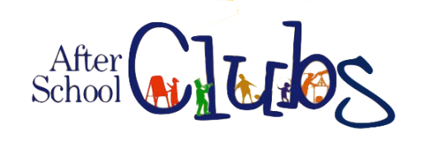

Autumn 2022
We are currently deciding what clubs will be available this term. As soon as the final list is complete any available clubs will be posted on class dojo pages and posted on the school website,
We are looking to start our afterschool club provision as soon as possible.


