**PSHEE**

Our theme is ‘I can be myself’ and we will be learning about a positive self image and appreciating that we’re all unique.

**History**

We continue learning about Britain in the Bronze and Iron Age, particularly the Hill Fort at Mam Tor in the Peak District.

**PE**

We will be developing throwing and catching skills and then using them when playing team games. It is 3M’s turn to go to swimming lessons.

**Geography**

We will be learning about how volcanoes are formed and what happens when they erupt. We will consider the pros and cons of living near a volcano.

**English**

Our key Pathways to Writing text is ‘Big Blue Whale’ by Nicola Davies. We will also be reading ‘This morning I met a whale’. We will learn about the features of information texts and about persuasive language. We will then use information from our books and other sources to write an information leaflet, persuading people to protect whales.

**RE**

We will be recognising and identifying some differences between religious festivals and celebrations.

**Computing**

We will be discerning researchers and present our findings in text and different ways of displaying data, eg graphs and pie charts.

**Maths**

We will start to use formal written methods, using an expanded column method for addition. We will also a grid method to multiply two-digit numbers by one digit numbers, using the times tables multiplication facts that we continue to learn and test each week.

**We will Rock You Spring 2**

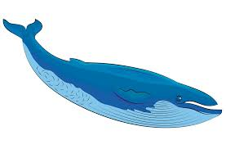

**Design and Technology**

We will reinforce what we have learnt about healthy diets in science, designing and making healthy stir fries.

**Science**

We will investigate healthy diets for humans and other animals. We will also look at the role of the skeleton and patterns in body sizes.