Science News Letter Spring 2022
Lots more science happened in the second half of last term.
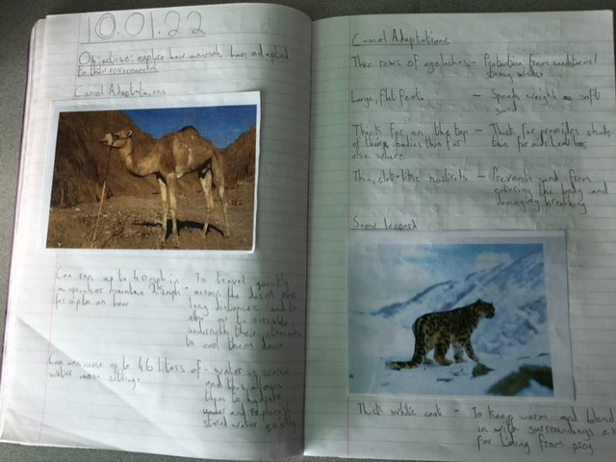
How have different animals evolved and adapted to suit their environments?
Lots of hands-on materials investigations.
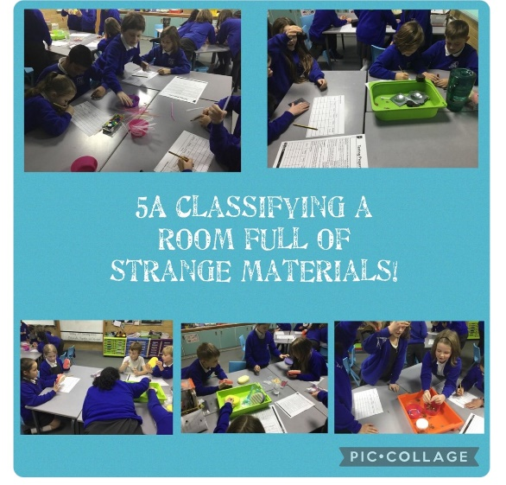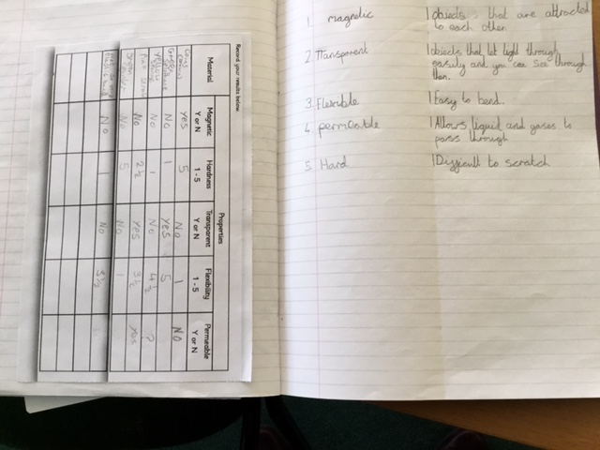
Upper Key Stage 2
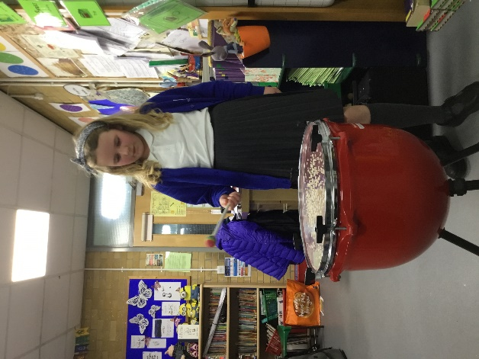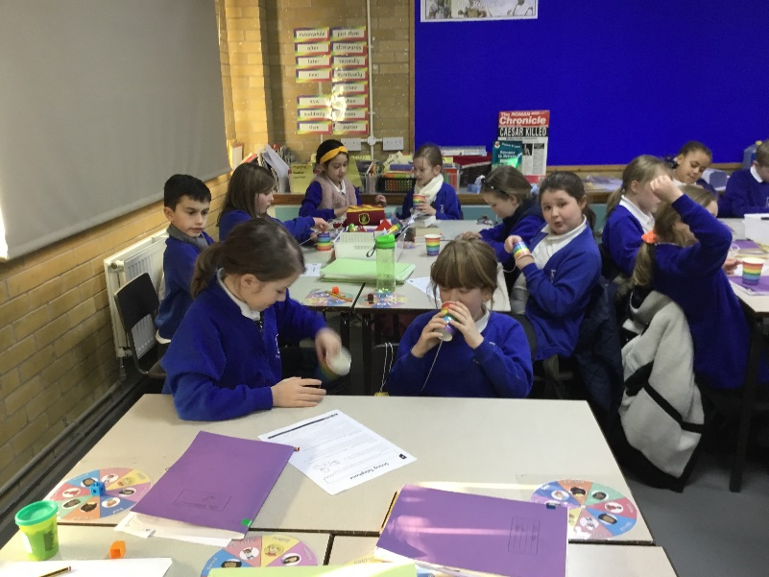
We know lots about how sounds are made, how they travel and how they can be changed.
We also enjoyed reflecting light, changing its colour, and finding out about shadow formation.

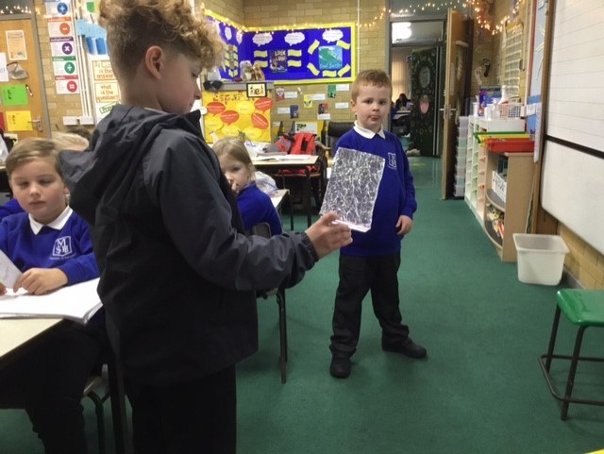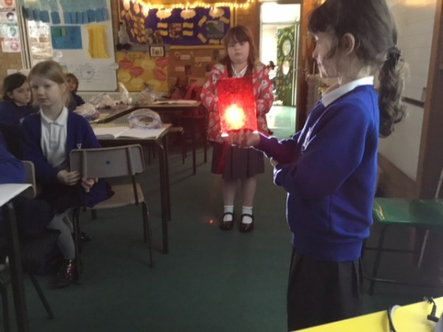

Lower Key Stage 2
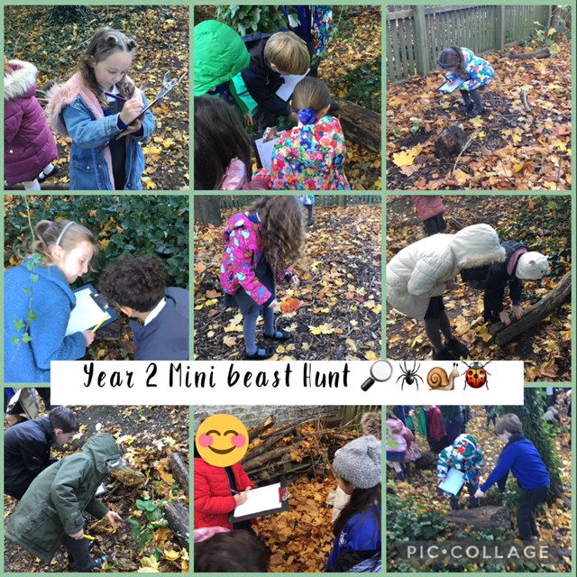
We used our careful observational skills when finding minibeasts. We love being outside.
We were inspired by disabled artists and paralympians to investigate if we could use our feet to do some of the things are hands usually do.

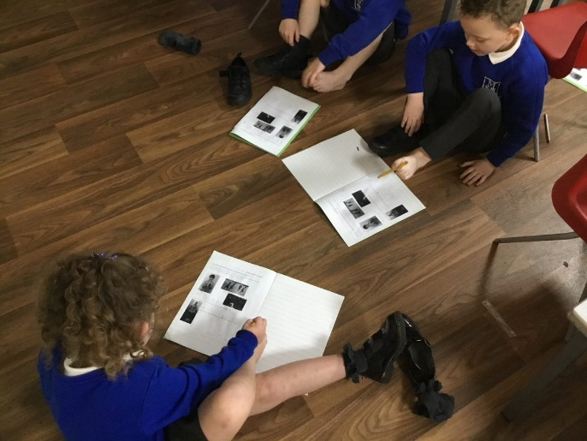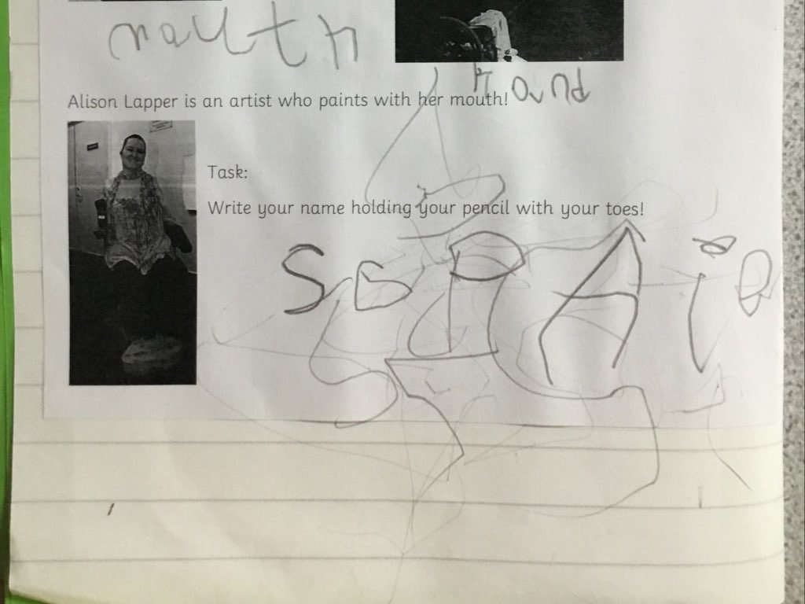
Key Stage 1
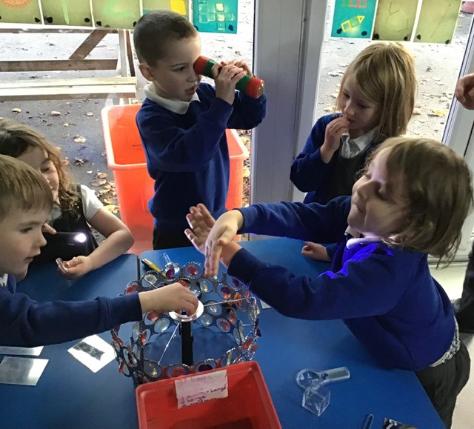
Early experiences of light and dark, reflections and shadows, using mirrors, kaleidoscopes and torches.
Early Years Foundation Stage

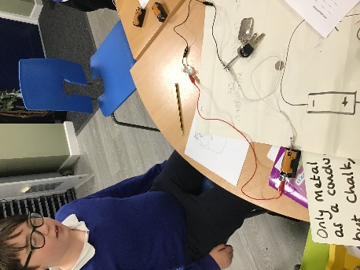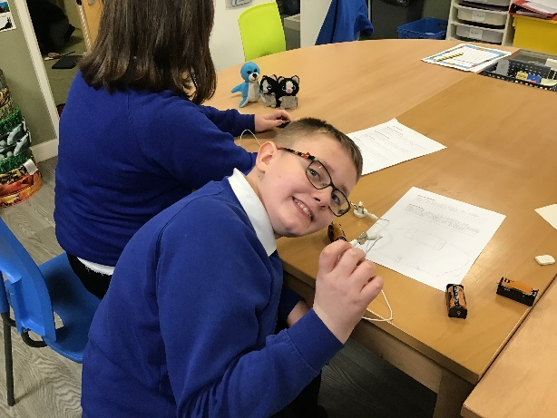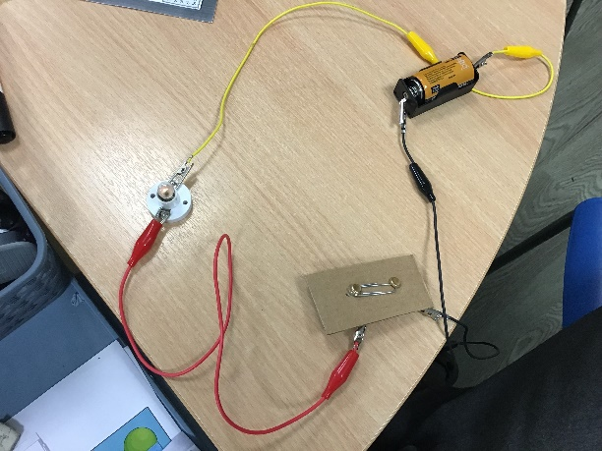
Hive
Even though we can’t have visitors in school due to Covid, that isn’t stopping us finding out more about science careers. Lots of our classes have booked to spend some time with STEM Ambassadors, via online sessions for Spring 1.
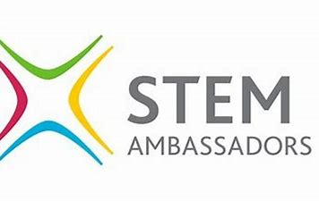
We are so lucky in our school. Two of our parents are STEM Ambassadors, and have been into school to talk about their jobs and support children’s learning with resources we haven’t got in school. Lots of our parents work in STEM (Science, Technology, Engineering and Maths) careers. If you would be willing to talk about your job, or even take photos or make a short video explaining what you do, we would be so appreciative. We are finding a real interest in medical and scientific careers as a result of the pandemic. Please let Mrs McLain (STEM lead) know, via the office or by emailing ao@smhsch.co.uk

