**PE**

After a two year gap, we can finally take children swimming again. 3T will swim before half term, 3M after half term.

**Geography**

We will be focusing on human geography. We will learn about different zones that the world is divided into and how that affects the life of people there.

**English**

Our key Pathways to Writing text is ‘Stone Age Boy’ by Satoshi Kitamora. In this book a boy from modern times falls back to the stone age. We will explore the structure and vocabulary of the book, write and punctuate conversations between characters, write diary entries and eventually write a historical story from the boy’s point of view.

**Religious education**

We will be exploring the question ‘Why is the Bible important for Christians today? ‘We will give examples of how and suggest reasons why Christians use the Bible today.

**Computing**

We continue to use coding to create and control animations. We talk about debugging code, and encourage the children to predict and then investigate what they are coding.

**Maths**

We continue to build our fast recall of times tables, doubling the two times table to learn the four times table, and then the eight times table. We will learn about fractions, learn how many of each fraction makes a whole, place fractions on a numberline, and use diagrams to find equivalent fractions.

**PSHEE**

We explore life in modern day Britain, understanding what is a diverse society and talk about why it is important to be respectful.

**We will Rock You**

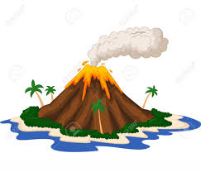

**Art**

We will be doing some three-dimensional work in air drying clay, investigating texture, sculpting and then painting dinosaur eyes.

**History**

We will look at the changes as people developed from the Stone Age to the Iron Age in early Britain.

**Science**

We will investigate the properties of different types of rocks and soils, and group them. We will find out how fossils are formed.