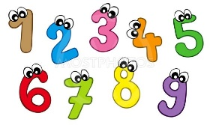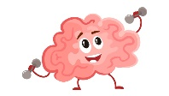 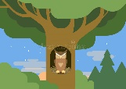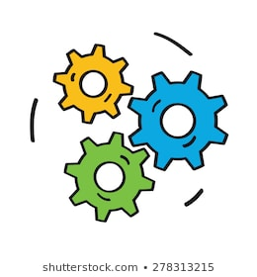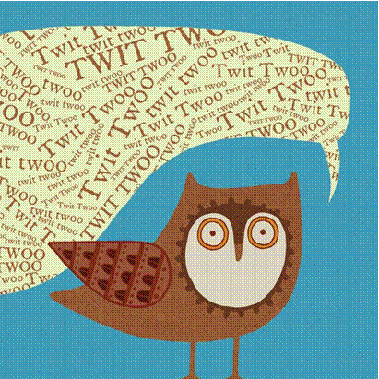

**Maths**

We will continue exploring place value and addition and subtraction. We will be looking at 3D shape, measurement, length using centimetres and metres, money and multiplication including our 2, 5 and 10 times tables. We will be problem solving using reasoning and logic skills with our Friday ‘Chilli Challenge’.

**English** – **Our spelling quiz will continue to be each Friday. Book bags should be returned to school every Friday.** This half term we will be using the story The Owl Who Was Afraid of the Dark by Jill Tomlinson. We will write for different purposes and audiences and make simple additions, revisions and corrections to our writing. We will continue to use adjectives, conjunctions, expanded noun phrases, adverbs and correct punctuation to make our writing more interesting. Also we will look at some poetry based around The Owl and the Pussycat.

**P.E - Our P.E sessions will continue to be on Thursdays. Please ensure your child comes to school dressed in plain dark coloured joggers/ leggings, a plain white t-shirt/ polo-shirt, school jumper/cardigan and trainers.**

This half term the children will be taking part in Dance linked to the gun powder plot. We will dance to different rhythms and tempos and use our bodies to produce rhythm on our own and as a whole class.

**Computing**

The children will be continuing to learn about how to keep themselves safe online and sending a

secure email to Santa.

**PSHE and Wellbeing**

In PSHE, the children will learn all about staying safe at home, outside and online. We will recognise that we share a responsibility for keeping ourselves and others safe. We will continue with our wellbeing activities such as yoga, meditation, circle time and mindfulness art.

**Science**

The children will be learning about habitats. We will be Identifying and naming a variety of plants and animals in their habitats, including micro-habitats.

**History**

We will be looking at a historical event beyond living memory – The Gun Powder Plot. We will sequence events and extend our speaking, listening and thinking skills through discussion and debate.

**R.E**

We be finding out

all about why light is important in different religions.

**Geography**

In geography, we will be comparing a small area of the UK with a small area in a contrasting non-European country. We will compare the owls we have here in the UK and the owls abroad focusing on the climate differences.

**D&T**

The Children will explore and evaluate a range of existing bird feeders then design and make their own suitable product.

**Twit Twoo where are you?**

**Year 2 Autumn 2**