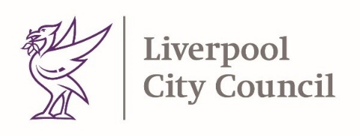

4th March 2021

Dear Parents and Carers
Thank you for your continued support in the fight against Coronavirus. Schools are working hard to welcome back children from 8th March 2021. Arrangements will vary slightly from school to school. Your school will be in touch with you through their normal methods of communication, for example by letter or the school website.
It is still important that we continue to keep ourselves and others safe. Please continue to follow all Coronavirus prevention guidelines, maintain social distancing and wear face coverings wherever possible.
School Testing

Upon return, secondary school aged children will be offered a series of three tests at their school under the supervision of a trained operator. Testing is voluntary, and consent must be provided for your child directly to the school.

Following on site testing, children may then continue taking twice-weekly tests using a home test kit provided by their school. You will receive further information about how to participate directly from your school.

Household testing

If you’re a member of a household, childcare bubble or support bubble of a member of school staff or a pupil you can now access testing twice weekly. Further details can be found here:
https://www.gov.uk/guidance/rapid-lateral-flow-testing-for-households-and-bubbles-of-school-pupils-and-staff?priority-taxon=774cee22-d896-44c1-a611-e3109cce8eae
Testing is voluntary, but we strongly encourage people to access testing available to them.

For a reminder about Coronavirus symptoms and how to get tested please see page 2.

Please stay safe and thank you for your continued support.

Yours Sincerely
Steve Reddy
Director of Children’s Services, Liverpool City Council

Matt Ashton
Director of Public Health, Liverpool
Page 2
General Covid-19 advice
If you have any of the main symptoms of coronavirus (COVID-19), get a PCR test as soon as possible. Stay at home until you get the result.
The main symptoms of coronavirus are:
- a high temperature – this means you feel hot to touch on your chest or back (you do not need to measure your temperature)
- a new, continuous cough – this means coughing a lot for more than an hour, or 3 or more coughing episodes in 24 hours (if you usually have a cough, it may be worse than usual)
- a loss or change to your sense of smell or taste – this means you've noticed you cannot smell or taste anything, or things smell or taste different to normal

People who are sick with coronavirus may have other flu like symptoms such as:
- body aches
- persistent headaches
- sore throat
- tiredness
- shortness of breath
- nausea or
- diarrhoea

If you don’t have any of the main symptoms of coronavirus, you don’t need to isolate until you get your result, however you do need to continue to take the usual measures to protect yourself and others from illness.

People with symptoms can get a test here:
https://liverpool.gov.uk/communities-and-safety/emergency-planning/coronavirus/how-to-get-tested/tests-for-people-with-symptoms/

People without symptoms can access our community testing sites here:
https://liverpool.gov.uk/smarttesting

Mental wellbeing
Parents needing extra care? Don’t forget about your own self-care. Discover our supportive online mental wellbeing space for adults: qwell.io

