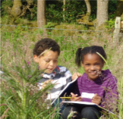
My Special Place
Choose a special place that is going to be your spot in the garden which you can return to again and again to observe everything around you. If you do not have a garden, you could find somewhere on your daily walk.
Hopefully it will be somewhere you can touch, feel, see and smell everything around you.
On this first time try doing some of these:-
- Close your eyes, what can you hear?
- Look up at the sky and think of words to describe the clouds, colours, patterns that you can see.
- What can you smell where you sit, closer to the ground, if you pick a handful of grass for instance?
- And what surfaces can you touch?
- Brush aside leaves, soil, turn over stones or logs that may be very close to you. What insects can you find?
- Which creatures do not come close to you and stay away more than 2 metres? Can you name the birds?
- You should take paper or a note book to record what you see. A magnifying glass if you have one to look at creatures. You could try and make up a poem about your special place
- You could decorate the edge of your paper with colours from smudging grass, leaves , mud and flowers.
- Finally, think of how you can mark your out Special Place.
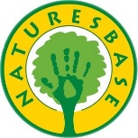
Naturesbase Education Centre www.naturesbaseeducation.co.uk

To Parents

This is a very simple activity but often very effective at helping you and your child slow down and connect with the natural world. You can sit alongside them and help with the collection of words and thoughts that describe what they are doing. You could record alongside them and perhaps help in writing or recording the findings.
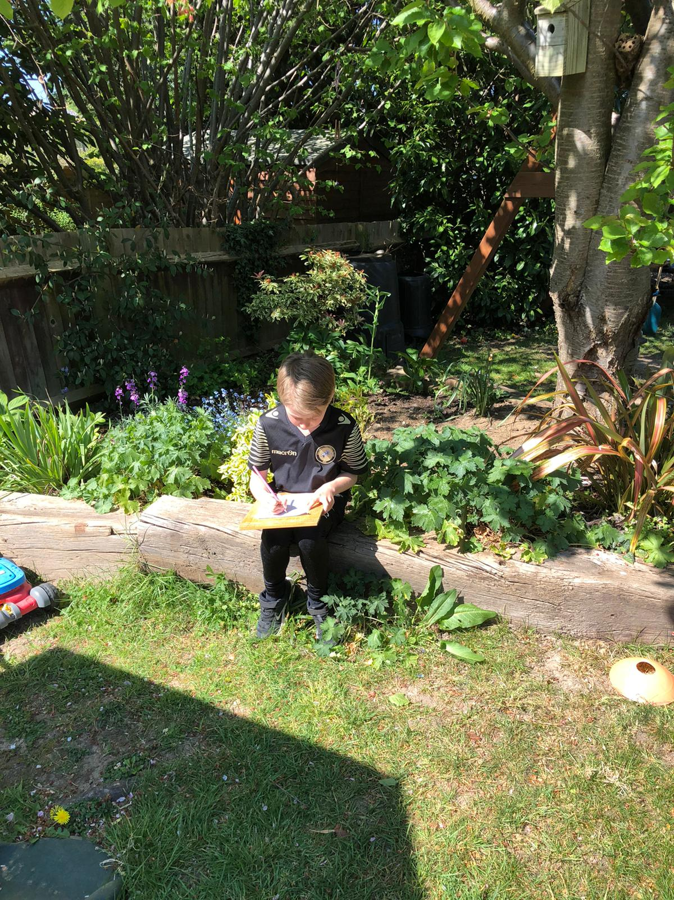

Here are some examples from Special Places recorded by a child in London.
Oliver (Age 9) wrote
‘Dear Dairy.
Today I completed the garden challenge sitting behind Izzy’s house and took close notice of the world around me.
My third challenge was to absorb the smells around me which was interesting. I got the sweet smell of sweetness coming from the pollen, grass and the barbecue!
My fourth challenge was to turn over wood and rocks. I don’t find much but I did find tons of ants, woodlice, more ants and a snail.
My second to last challenge was to look out for birds that do not come within two metres from me. Guess what I saw? A wood pigeon, robin, blackbird, goldfinch and a parakeet!
I would mark my spotting spot by putting a fence of twigs around the area. So my six garden challenges have been completed and hope everyone enjoys it like me.
Until tomorrow dairy, Ollie’

